SIMATS ENGINEERING
ASSESSMENT TOOL 2

COURSE CODE: CSA14 COURSE NAME: Compiler Design

COURSE OUTCOME COVERED
CO1: Apply lexical analysis for token specification and recognition using LEX tool (BL3)
Assessment Tool Weightage: 20%

QUESTIONS: 3 Total Marks:50
Annexure A
ERROR ANALYSIS TASK

Code of Conduct:
I CH.GOWTHAM REDDY (192365064) certify that this submission is my original work and that I have adhered to the guidelines specified for this assessment.
I understand that any violation of academic integrity rules will result in disciplinary action.

Signature of the student: CH.GOWTHAM REDDY

Question 1

Q1. The following program is intended to perform simple arithmetic operations, function calls, array access, and looping constructs. However, the code contains multiple errors introduced at different phases of compilation, including lexical, syntax, semantic, logical, and runtime errors.
Given Program :
#include <stdio.h>

int sumArray(int arr[], int n) {
int i, sum = 0;
for(i = 0; i <= n; i++) {
sum = sum + arr[i];
}
return sum;
}

int main() {
int arr[5] = {1,2,3,4,5}
int total;

total = sumArray(arr);

if(total == 15) {
printf("Correct Sum\n")
}

int a = 10, b = 0;
int c = a / b;

int *p;
*p = 20;

return 0;
}
Tasks:
(a) Error Identification (Analysis Level)
- Identify all the errors present in the program. For each error:
- Specify the line number
- Clearly describe the nature of the error
(b) Classification of Errors (Understanding + Analysis)
- Classify each identified error into the appropriate compiler phase:
- Lexical Errors
- Syntax Errors
- Semantic Errors
- Logical Errors
- Runtime Errors
(c) Compilation Behavior (Evaluation Level)
- Analyze which errors will be detected during compilation and which will only appear during execution.
- Explain how early-stage errors (lexical/syntax) may prevent detection of later-stage errors.
(d) Code Correction (Application Level)
- Rewrite the corrected version of the program such that:
- All errors are removed
- The program executes correctly
- Proper syntax and semantics are maintained
(e) Impact Analysis (Evaluation Level)
- Discuss the impact of at least three errors on program execution.
- Explain how incorrect constructs like improper pointer usage, division by zero, and infinite loops affect system behavior.
(f) Advanced Compiler Perspective (Create Level)
- Suggest how a compiler can be improved to:
- Provide better error messages
- Perform early detection of runtime errors
- Propose at least two enhancements in compiler design for efficient debugging.

Answer 1

Error analysis
The program sums an array, tests the result, divides two numbers and writes through a pointer. It contains syntax, semantic, logical and runtime errors, and no lexical errors. Line numbers below count from #include <stdio.h> as line 1 of the given program.
(a) Error identification
Line | Code | Nature of error | Explanation
5 | i <= n | Logical | The array has n elements (indexes 0 to n-1), but the loop also runs for i = n.
6 | arr[i] with i = 5 | Runtime | Reads arr[5], which is outside the array (undefined behaviour).
12 | int arr[5] = {1,2,3,4,5} | Syntax | The declaration is not terminated by ;.
15 | sumArray(arr) | Semantic | The function needs two arguments (array and n); only one is passed.
18 | printf("Correct Sum\n") | Syntax | Statement is missing the closing ;.
22 | a / b with b = 0 | Runtime | Integer division by zero.
24–25 | int *p; *p = 20; | Runtime | p is uninitialised, so it points to an unknown address and the write is undefined behaviour.

Root cause of each error
- Off-by-one loop. With n = 5 the loop uses i = 0 to 5, but valid indexes are 0 to 4. The condition must be i < n.
- Missing semicolons (lines 12 and 18). C needs ; to end declarations and expression statements, so the parser cannot finish the statement.
- Wrong argument count (line 15). sumArray is declared with (int arr[], int n), so a call with one argument does not match the declaration.
- Division by zero (line 22). b is initialised to 0, so a / b divides by zero.
- Wild pointer (lines 24–25). p holds an indeterminate address and is dereferenced before it points to valid memory.
(b) Classification of errors
Error | Type | Compiler phase that handles it
Missing ; at line 12 | Syntax | Syntax analysis (parser)
Missing ; at line 18 | Syntax | Syntax analysis (parser)
Too few arguments in sumArray(arr) | Semantic | Semantic analysis (type/argument check)
i <= n | Logical | Not detected by the compiler; program logic
arr[5] access | Runtime | Execution
Division by zero | Runtime | Execution
Uninitialised pointer p | Runtime | Execution
Write through *p | Runtime | Execution
Lexical errors: none. Every token in the program (keywords, identifiers, constants, operators, string literal) is valid.
(c) Compilation behaviour
Detected at compile time: the two missing semicolons (syntax) and the wrong number of arguments (semantic). The compiler reports these and does not produce an executable.
Appear only during execution: the out-of-range access arr[5], division by zero (a SIGFPE crash on most systems) and the write through the uninitialised pointer (often a segmentation fault). The loop condition i <= n is a logic mistake, so no compiler message exists for it.
Why early errors hide later ones: a compiler works in order: lexical analysis, syntax analysis, semantic analysis, code generation. If the parser fails on a missing ;, it may not build a valid syntax tree for the following statements. Semantic analysis (such as the argument-count check) then works on incomplete or recovered input, so its errors may only show after the syntax errors are fixed. Runtime errors cannot appear at all until the program compiles and runs.
(d) Corrected program
#include <stdio.h>
int sumArray(int arr[], int n) {
int i, sum = 0;
for (i = 0; i < n; i++) {
sum = sum + arr[i];
}
return sum;
}
int main() {
int arr[5] = {1, 2, 3, 4, 5};
int total;
total = sumArray(arr, 5);
if (total == 15) {
printf("Correct Sum\n");
}
int a = 10, b = 2;
int c = a / b;
printf("Result = %d\n", c);
int value = 20;
int *p = &value;
*p = 20;
printf("Pointer value = %d\n", *p);
return 0;
}

Expected output
Correct Sum
Result = 5
Pointer value = 20

Implementation screenshot:
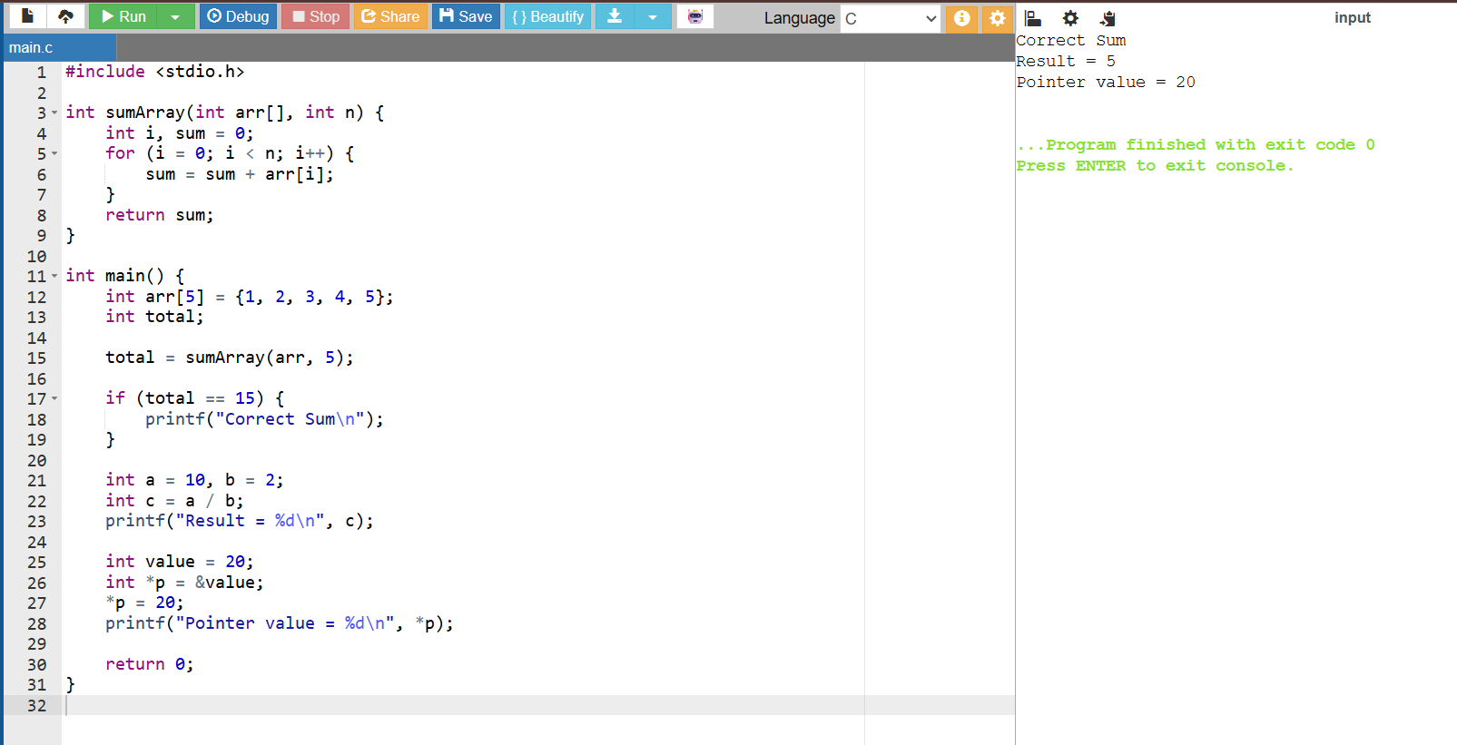
(e) Impact analysis
- Division by zero. The CPU raises an arithmetic exception, so the operating system terminates the program abnormally and any output or work after that line is lost.
- Improper pointer usage. Writing through an uninitialised pointer can overwrite unrelated memory, corrupt data or cause a segmentation fault. The behaviour is undefined, so it may seem to work on one run and crash on the next.
- Array bounds violation. Reading arr[5] pulls a garbage value into the sum, so total may not equal 15 and the check fails silently. Writing outside an array would corrupt neighbouring variables.
- Infinite loops (general case). A loop whose condition never becomes false keeps the CPU busy forever, so the program hangs and the system becomes slow or unresponsive until the process is killed. (Q1 itself has no infinite loop; the closest case is the unbounded i <= n index running past the array.)
(f) Advanced compiler perspective
- Better error messages. Report line and column, the exact problem, the likely cause and a fix. For line 12: "Error at line 12: expected ';' after array declaration. Add ';' at the end of the statement." This is better than a bare "syntax error".
- Early detection of runtime errors. Add a static-analysis pass that warns about constant division by zero, use of uninitialised pointers and variables, and constant array indexes outside the declared size, so b = 0 followed by a / b is flagged before the program runs.
- Enhancement 1: static analysis and data-flow checks during compilation, to catch unreachable code, uninitialised use and out-of-range constant indexes.
- Enhancement 2: sanitizer and debug support. Offer built-in runtime checking (address and undefined-behaviour sanitizers) that reports invalid memory accesses with the source line and variable name.

Question 2

Q2.The following C program contains multiple lexical errors introduced intentionally. These errors occur due to invalid tokens, incorrect identifiers, malformed constants, and illegal symbols, which are typically detected during the lexical analysis phase of a compiler.Carefully examine the program and answer the questions given below.
#include <stdio.h>

int main() {
int 1num = 100;
float rate@ = 25.5;
char ch = 'abc';
int total = 50$20;
int num#1 = 30;
int %count = 40;

printf("Welcome to Compiler Design);

int x = 09;
int y = 0xZ12;
int z = 12.3.4;

char str1[] = "Hello;
char str2[] = "World";

int _valid = 10;
int invalid-id = 20;

float value = 5.6;
int data = 10@5;

char c = 'xy';
int 3value = 60;

printf("Value: %d\n", total);

return 0;
}
Tasks
(a) Error Identification
i) Identify all lexical errors in the program.
ii) List the line number and the invalid token.
(b) Error Classification
i) For each error, explain why it is considered a lexical error.
ii) Specify which rule of token formation is violated:
iii) Identifier rules
iv) Constant formation
v) String/character literal rules
vi) Operator/symbol rules
(c) Token Correction
i)Rewrite each invalid token into a valid token.
ii)Example: 2value → value2
(d) Compiler Behavior Analysis
i) Explain how a lexical analyzer (scanner) processes such errors.
ii)Discuss whether the compiler:
iii)Stops immediately
iv)Continues scanning using error recovery
(e) Advanced Thinking
i) Design a simple rule (or DFA idea) to detect invalid identifiers starting with digits.
ii) Suggest how error messages can be improved for beginners.

Answer 2. Lexical error analysis
The program contains invalid identifiers, malformed numeric constants, bad character and string literals, and illegal symbols. The lexical analyser (scanner) groups characters into tokens, and each item below breaks one of its token-formation rules. Line numbers count from #include <stdio.h> as line 1.
(a) Error identification
Line | Invalid token / construct | Error
4 | 1num | Identifier starts with a digit
5 | rate@ | @ is not allowed in an identifier
6 | 'abc' | More than one character in a character literal
7 | 50$20 | $ is not a valid operator and cannot join two numbers
8 | num#1 | # is not allowed in an identifier
9 | %count | % is an operator and cannot begin an identifier
11 | "Welcome to Compiler Design) | Unterminated string literal (closing " missing)
13 | 09 | Invalid octal constant (digit 9 after leading 0)
14 | 0xZ12 | Invalid hexadecimal constant (Z is not a hex digit)
15 | 12.3.4 | Malformed floating-point constant (two decimal points)
17 | "Hello; | Unterminated string literal
21 | invalid-id | - is an operator, so this is read as invalid - id, not one identifier
23 | 5..6 | Malformed floating-point constant
24 | 10@5 | Illegal symbol @ inside a constant
26 | 'xy' | More than one character in a character literal
27 | 3value | Identifier starts with a digit

(b) Error classification
Each error is a lexical error because the scanner cannot form a valid token from the characters. The rule violated is:
Rule violated | Tokens | Why
Identifier rules | 1num, 3value, rate@, num#1, %count, invalid-id | An identifier is a letter or _ followed by letters, digits or _. It cannot start with a digit or contain @, # or -.
Constant formation | 09, 0xZ12, 12.3.4, 5.6, 10@5 | Octal allows only 0–7, hex only 0–9 and A–F, and a real constant has one decimal point.
String / character literal rules | 'abc', 'xy', "Welcome to Compiler Design), "Hello; | A character literal holds one character, and a string must be closed by " on the same line.
Operator / symbol rules | 50$20, @, #, % | These symbols cannot appear where the program places them.

(c) Token correction
Invalid token | Valid token
1num | num1
rate@ | rate
'abc' | 'a'
50$20 | 50 + 20
num#1 | num_1
%count | count
"Welcome to Compiler Design) | "Welcome to Compiler Design"
09 | 9
0xZ12 | 0xA12
12.3.4 | 12.34
"Hello; | "Hello"
invalid-id | invalid_id
5..6 | 5.6
10@5 | 10 + 5
'xy' | 'x'
3value | value3

(d) Compiler behaviour analysis
The scanner reads the source one character at a time and matches the longest valid token. For int value = 10; it returns int (keyword), value (identifier), = (operator), 10 (constant) and ; (delimiter). When the characters match no token pattern, such as 3value, it reports a lexical error with the line number.
The compiler does not have to stop at the first error. With error recovery (for example, skipping the bad character or discarding up to the next delimiter), the scanner keeps going and reports many errors in one run, so the programmer can fix several at once. For example: "line 4: invalid identifier '1num'", "line 5: illegal character '@'", "line 14: invalid hexadecimal constant". Serious errors such as an unterminated string can make the scanner lose token boundaries and trigger extra, misleading errors on the lines after it.

Corrected code
#include <stdio.h>
int main() {
int num1 = 100;
float rate = 25.5;
char ch = 'a';
int total = 50 + 20;
int num_1 = 30;
int count = 40;
printf("Welcome to Compiler Design\n");
int x = 9;
int y = 0xA12;
float z = 12.34;
char str1[] = "Hello";
char str2[] = "World";
int _valid = 10;
int invalid_id = 20;
float value = 5.6;
int data = 10 + 5;
char c = 'x';
int value3 = 60;
printf("Value: %d\n", total);
return 0;
}

Expected output
Welcome to Compiler Design
Value: 70

Implementation screenshot:
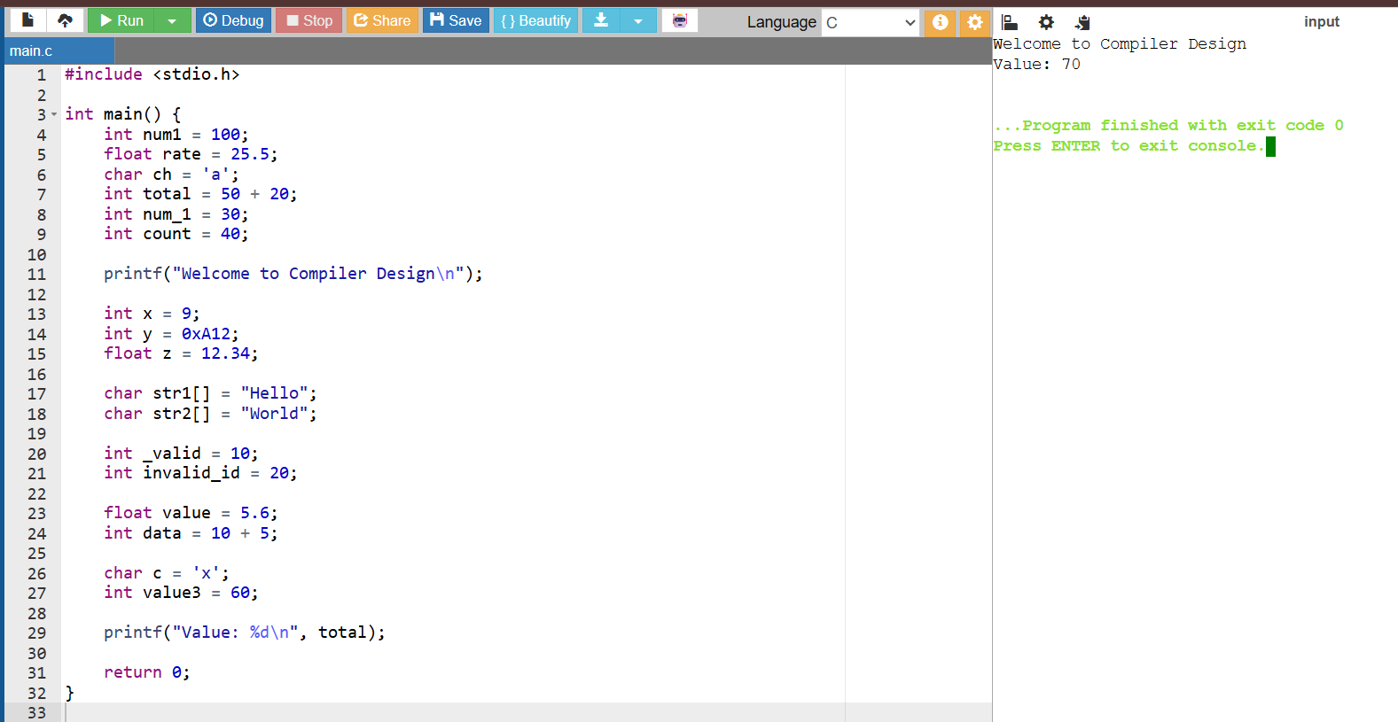

(e) Advanced thinking
Rule / DFA for identifiers that start with a digit. A valid identifier matches [A-Za-z_][A-Za-z0-9_]*. A digit-led identifier matches [0-9]+[A-Za-z_][A-Za-z0-9_]* and should be reported. The DFA has three states:
State | Meaning | On digit | On letter or _ | On other
q0 | Start | q1 | q3 (valid identifier) | Handled by other rules
q1 | Number read so far | q1 | q2 (error) | Accept as number
q2 | Error: digit-led identifier | q2 | q2 | Report error and stop token

Question 3

Q3. The following C program is designed to perform arithmetic operations, function calls, conditional checks, pointer usage, and looping. However, the program contains multiple errors distributed across different phases of a compiler, including:
- Lexical Errors
- Syntax Errors
- Semantic Errors
- Intermediate Code Generation Issues (logic/precedence)
- Code Optimization Issues (redundancy/inefficiency)
- Runtime / Target Code Errors
Carefully analyze the program and answer the questions below.

#include <stdio.h>

int divide(int a, int b) {
return a / b
}

int main() {
int #value = 20;
float num = 15.5
int result;

result = divide(10);

if(result = 5) {
printf("Result is 5\n")
}

int x = 10;
int y = 0;
int z = x / y;

int arr[4] = {1,2,3,4};
printf("%d\n", arr[4]);

int *ptr;
*ptr = 25;

int total;
total = x + y * result + 0;

while(x < 20) {
printf("%d\n", x);
}

return 0;
}
Do the following Tasks
(a) Identify Errors (Analysis Level)
- Identify all errors in the program.
- Mention line number + error description.

(b) Classify by Compiler Phase
Classify each error into:
- Lexical (invalid symbols like @num)
- Syntax (missing semicolon, brackets)
- Semantic (function argument mismatch)
- Intermediate Code Issues (wrong expression handling/precedence)
- Optimization Issues (redundant + 0)
- Runtime Errors (division by zero, invalid pointer access)

(c) Compilation vs Execution (Evaluation)
- Which errors are detected at compile time?
- Which errors appear only during execution?
- Explain why some errors prevent further compilation.

(d) Correct the Program (Application)
- Rewrite the fully corrected program.
- Ensure:
  - Proper syntax
  - Correct semantics
  - Safe execution

(e) Deep Analysis (Evaluation)
- Explain how incorrect pointer usage affects runtime.
- Analyze how array bounds violation impacts memory.
- Discuss how operator precedence errors affect intermediate code.

(f) Advanced Task (Create Level)
- Suggest 2 improvements in compiler design to:
  - Detect runtime errors earlier
  - Improve debugging messages
- Propose how optimization phase can remove redundant expressions.

Answer 3. Multi-phase compiler error analysis
The program has errors in the lexical, syntax, semantic, intermediate-code (expression handling), optimization and runtime phases. Line numbers count from #include <stdio.h> as line 1.
(a) Identify errors
Line | Code | Error description
4 | return a / b | Missing ;
8 | int #value = 20; | # is invalid in an identifier
9 | float num = 15.5 | Missing ;
12 | divide(10) | Function needs two arguments, one given
14 | if(result = 5) | Assignment used where comparison (==) is meant
15 | printf("Result is 5\n") | Missing ;
20 | x / y with y = 0 | Division by zero
23 | arr[4] | Array of size 4 has valid indexes 0–3
25–26 | int *ptr; *ptr = 25; | Uninitialised pointer is dereferenced
28 | + 0 | Redundant operation
29–31 | while(x < 20) | x never changes, so the loop never ends

(b) Classification by compiler phase
Line | Error | Classification
8 | #value | Lexical
4, 9, 15 | Missing ; | Syntax
12 | divide(10) | Semantic (argument mismatch)
14 | result = 5 in the condition | Intermediate-code / logic issue (wrong expression handling)
28 | + 0 | Optimization issue (redundant expression)
20 | Division by zero | Runtime
23 | arr[4] | Runtime (out of bounds)
26 | *ptr = 25 | Runtime (invalid pointer access)
29–31 | Infinite loop | Logical, shows up at runtime as a hang
Operator precedence. The expression x + y * result + 0 has no precedence error: C evaluates y * result first because * binds tighter than +, giving x + (y * result) + 0. The only problem in that statement is the redundant + 0. The real expression-handling error is result = 5 in the if: it assigns 5 and the condition is always true.
(c) Compilation vs execution
Detected at compile time: the invalid identifier #value, the missing semicolons on lines 4, 9 and 15, and the wrong argument count on line 12. A good compiler also warns about result = 5 in a condition.
Appear only during execution: division by zero (line 20), arr[4] out of bounds (line 23), the write through the uninitialised pointer (line 26) and the infinite loop (lines 29–31).
Why some errors stop further compilation: lexical and syntax errors break the token stream or the parse tree. Semantic analysis, intermediate-code generation and optimization all need a valid tree, so the compiler cannot reliably check the argument count on line 12 or optimise line 28 until the lexical and syntax errors are fixed. Compile errors also mean no executable is produced, so runtime errors cannot occur yet.
(d) Fully corrected program
#include <stdio.h>
int divide(int a, int b) {
if (b == 0) {
return 0;
}
return a / b;
}
int main() {
int value = 20;
float num = 15.5;
int result;
result = divide(10, 2);
if (result == 5) {
printf("Result is 5\n");
}
int x = 10;
int y = 2;
int z = x / y;
printf("Division result = %d\n", z);
int arr[4] = {1, 2, 3, 4};
printf("%d\n", arr[3]);
int number = 25;
int *ptr = &number;
printf("Pointer value = %d\n", *ptr);
int total;
total = x + y * result;
printf("Total = %d\n", total);
while (x < 20) {
printf("%d\n", x);
x++;
}
return 0;
}

Expected output
Result is 5
Division result = 5
4
Pointer value = 25
Total = 20
10
11
12
13
14
15
16
17
18
19

Implementation screenshot:
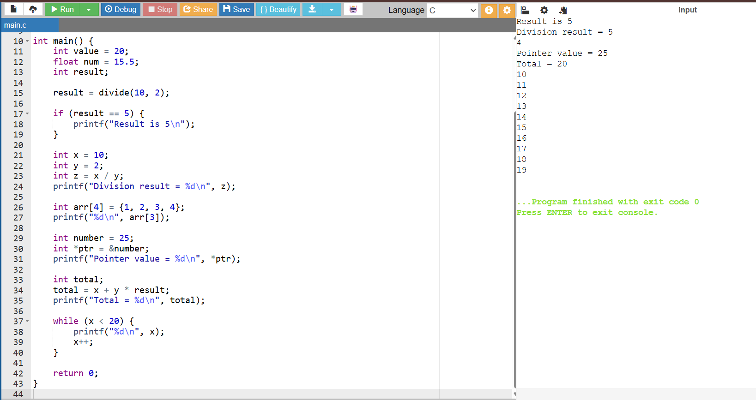
(e) Deep analysis
- Incorrect pointer usage. int *ptr; *ptr = 25; writes to whatever address happens to be in ptr. That can corrupt other variables, crash with a segmentation fault, or appear to work, because the behaviour is undefined. Fix: point it at a real object (int *ptr = &number;).
- Array bounds violation. arr[4] reads one element past the end of a 4-element array. C does no bounds checking, so the program reads whatever memory sits next to the array. The result is a garbage value, and a write there would corrupt neighbouring data or the stack. Fix: use arr[3] or a loop bounded by the array size.
- Operator precedence and intermediate code. For x + y * result + 0 the compiler's intermediate code follows precedence: t1 = y * result, t2 = x + t1, t3 = t2 + 0, total = t3. A wrongly handled expression, such as treating = as ==, would generate an assignment result = 5 followed by a branch that is always taken, so the intermediate code is correct for what was written but wrong for what was intended.
(f) Advanced task
- Detect runtime errors earlier. Add static analysis and data-flow checks that flag division by a constant zero (y = 0 then x / y), use of an uninitialised pointer, constant array indexes past the declared size, and loops whose condition variable is never changed, each with a warning at compile time.
- Improve debugging messages. Report line, column, error type, cause and a suggested fix, for example "Line 8: invalid identifier '#value'. '#' cannot be used in a C identifier. Suggestion: rename it to 'value'."
- Removing redundant expressions in the optimization phase. Algebraic simplification rewrites x + 0 as x, so total = x + y * result + 0 becomes total = x + y * result. Constant propagation can go further: since y is known to be 0, y * result folds to 0 and the whole statement reduces to total = x. The optimiser removes unneeded instructions without changing the program's result.

RUBRICS FOR CALCULATION:

Criteria | Weightage | Level 4 (Exemplary) | Level 3 (Proficient) | Level 2 (Developing) | Level 1 (Beginning)
Error Identification | 20% | Accurately identifies all errors with clear understanding of issues | Identifies most errors with minor omissions | Identifies limited errors; some are missed | Fails to identify key errors
Root Cause Analysis | 30% | Clearly explains underlying causes with strong technical reasoning | Explains causes with moderate clarity | Partial explanation; weak reasoning | Unable to identify causes of errors
Correction & Justification | 25% | Provides correct solutions with strong justification and logic | Provides correct corrections with some justification | Corrections are partially correct or weakly justified | Incorrect or no corrections provided
Application of Concepts | 15% | Effectively applies relevant concepts to analyze and resolve errors | Applies concepts with minor errors | Limited application; requires guidance | Unable to apply concepts
Clarity & Presentation | 10% | Presents analysis clearly, logically, and systematically | Generally clear with minor issues | Lacks clarity or proper structure | Poor presentation and difficult to understand

